**Energy Usage Checklist**

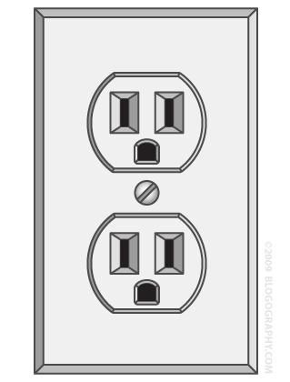 **How many electronics are plugged in? _________**

**What are they used for?**

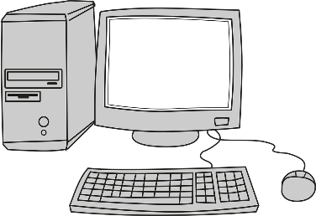 **How many computers are plugged in? _________**

 **How many lights are in the room? _________**

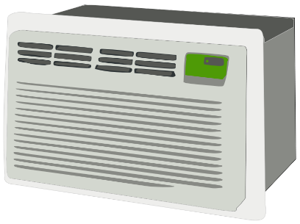 **Is there a heat and air-conditioning? _________**